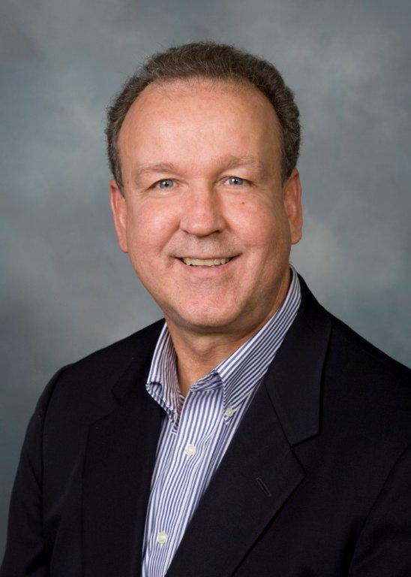

Gerald (Jerry) Daly, Senior Vice President, Optum, Hartford, CT
Jerry has over 30 years of experience in developing and managing relationships with senior business leaders across New England and the Northeastern U.S.
In his current role as Senior Vice President at Optum, Jerry is responsible for working with large organizations across the Northeast and New England to identify solutions for the health of their workforce. Jerry is very active across New England representing Optum in the marketplace to include building relationships with senior executives at all types of organizations.
In his previous role as Regional Vice President of National Accounts, Jerry was responsible for managing UnitedHealthcare’s National Account client book of business across New England. Jerry led a team of Strategic Client Executives who worked with clients on the design and execution of their health care strategy. Jerry is engaged with key business organizations such as The New England Council, The New England Employee Benefits Council., and The Northeast Business Group on Heath.
Jerry graduated from the University of Vermont with a B.S. in Business and received his MBA from Rensselaer Polytechnic Institute.

